**Location map: Pooncarie Road PP_2016_WENTW_004**

**Subject site Part Lot 1 DP 1193874**

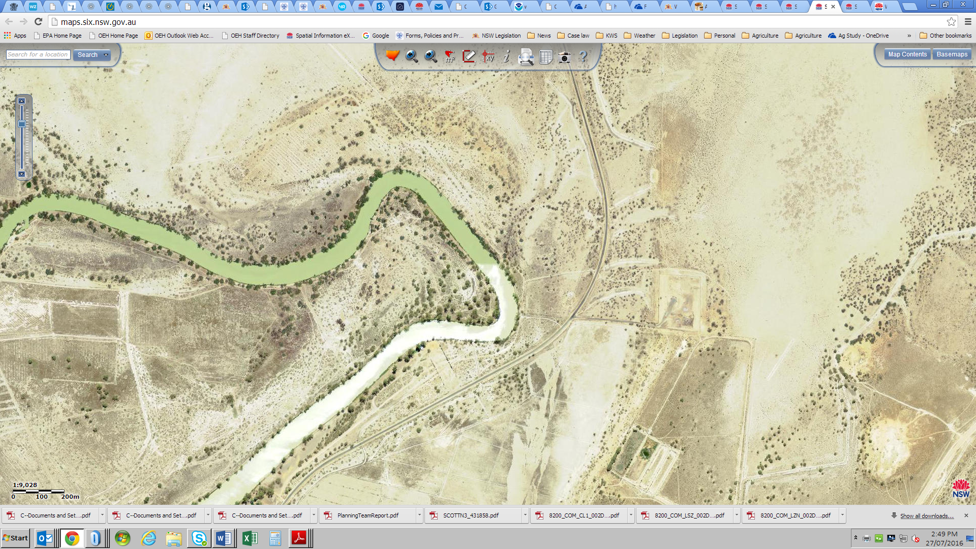**Darling** **River Pooncarie Road Wentworth township**